***IMAD5111 ASSIGNMENT ONE***

INTRODUCTION

The following document will outline my application's purpose using Android Studios. This application is purposely made to outline the history of certain individuals in the entertainment industry and the following document will outline the purpose the UI serves within the application and the “how to...” sections will outline the application into further details to give a broader outline of the application.

The Purpose of the UI In the Application

The UI in my application serves its purpose by being an attractive, built-in and well-planned application for users so that the application can link the content within the application. The UI in my application helps ease the user by providing an ability to navigate through the application, so that the user can navigate through the time periods, media types and historical context with ease. The UI in the application eases the user as it makes the application’s readability easier. The UI also is easier to access for users with disabilities. The UI can also create an interactive application with abilities like swiping up and down. The UI can also create an aesthetically pleasing application. Designing a great UI can create an application that is both practically functional and fun to use.

How used codes to create an application

How I used codes to create an application is that I firstly had to start off by declaring the view of the values in in application and those values were the buttons and the text vies and text results this is done so that users can interact with the application. I used strings for the buttons and the text views and the text multiline text. I also used the code “btn.” to creat an id for the buttons and then i used the codes “ageNumber”, “editText” and “textResults” for the text values that are within the code. I also used strings for the buttons and texts so that the main coding route can detect the values as stringed values.

How I ended up with errors in my code

How I ended up with errors within my code is that there are bugs within my application that don't allow me to run the application. These errors and bugs within the application are caused by incorrect values that have been put into the main code or the sub codes. As result of wrong inputs, the code provides me with an error. This could also be because of the wrong indentation being inserted within the code. This could also be because of the wrong IDs being inserted into the code.

Screenshot

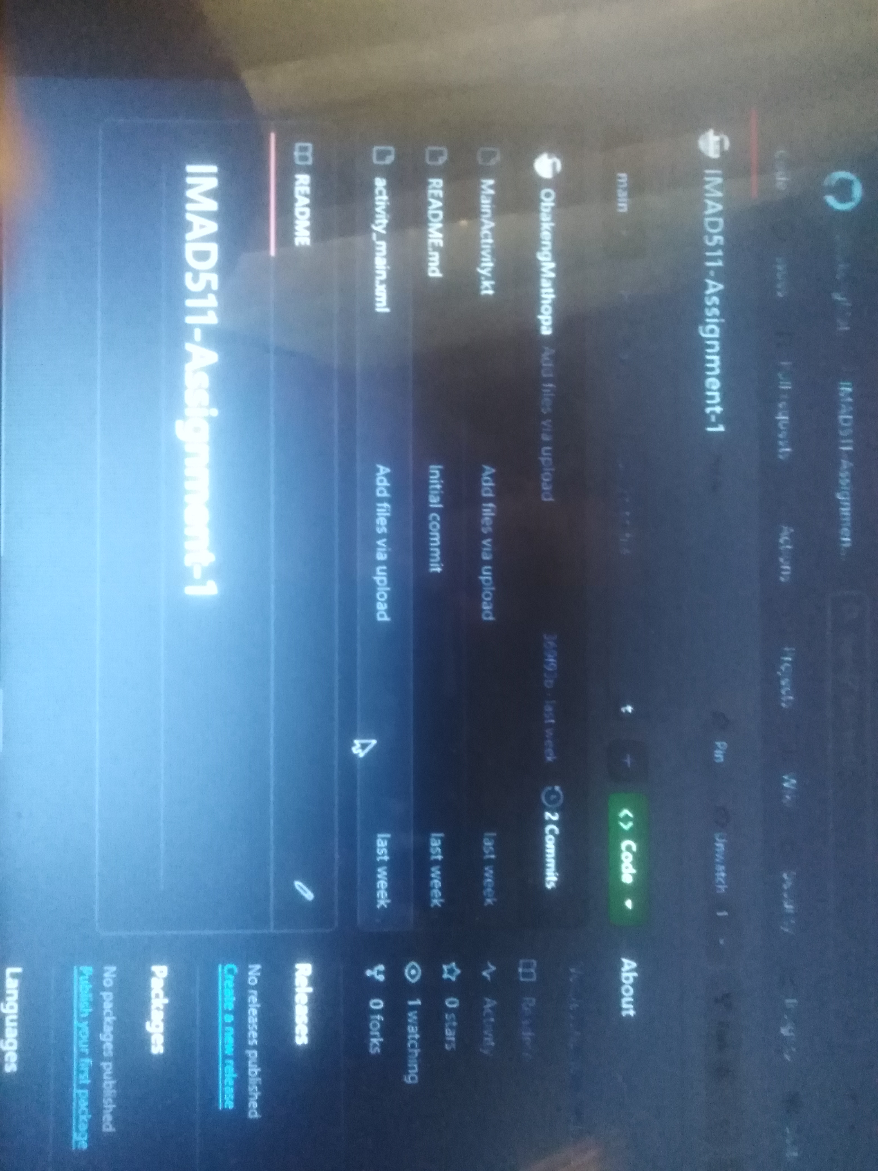

Conclusion

Due to unfortunate circumstances, I couldn't debug my app and alleviate the errors that are within my application.

GitHub Link

<https://github.com/ObakengMathopa/IMAD511-Assignment-1/upload/main>